TASK 1:
INCLUDE Irvine32.inc
.data
msg Byte "127&j~3#^&*#*#45^",0
prompt1 Byte "Index of input character is: ",0
prompt2 Byte "Not found!",0
.code
main PROC
call Scan_String
exit
main ENDP

Scan_String PROC
mov edi,offset msg
mov al,'#'
mov ecx,lengthof msg
mov ebx,ecx
cld
repnz scasb
jnz nfound
mov edx,offset prompt1
call writestring
call crlf
sub ebx,ecx
mov eax,ebx
call writedec
ret
nfound:
mov edx,offset prompt2
call writestring
call crlf
ret
Scan_String ENDP
END main

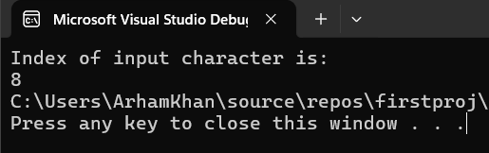
TASK 2:
INCLUDE Irvine32.inc

.data
str1 Byte "127&j~3#^&*#*#45^",0
prompt1 Byte "Index of input character is:",0
prompt2 Byte "Not found!",0

.code

main PROC
mov edi,offset str1
call readchar
call scan_string ; let's say * (which is at 11)
exit
exit
main ENDP

scan_string PROC USES edi eax
mov ecx,lengthof str1
mov ebx,ecx
cld
repnz scasb
jnz nfound
mov edx,offset prompt1
call writestring
call crlf
sub ebx,ecx
mov eax,ebx
call writedec
ret
nfound:
mov edx,offset prompt2
call writestring
ret
scan_string ENDP
END main

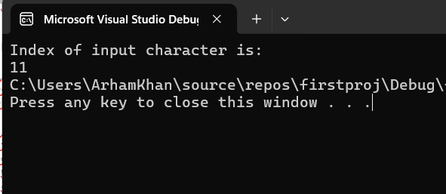
TASK 3:
INCLUDE Irvine32.inc

.data
str_cmp1 byte "Arham",0
str_cmp2 byte "Arham",0
prompt byte "Strings Matched!",0
prompt1 byte "The strings are not equal",0

.code
main PROC
call IsCompare
exit
main ENDP
IsCompare PROC
mov esi,offset str_cmp1
mov edi,offset str_cmp2
cmpsb
je equal
mov edx,offset prompt1
call writestring
ret
equal:
mov edx,offset prompt
call writestring
ret
IsCompare ENDP
END main
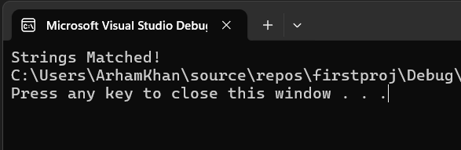
TASK 4:
INCLUDE Irvine32.inc
.data
rev_str byte "String 1",0
str2 byte "to be fi",0
prompt byte "reverse of 'string 1' is: ",0
.code

main PROC
mov edx, offset prompt
call writestring
call crlf
mov eax,0
call Str_Reverse
exit
main ENDP

Str_Reverse PROC
mov ebx,2
mov esi,offset rev_str
add esi,7
mov edi,offset str2
mov ecx,9
cld
l1:
lodsb
sub esi,2
stosb
loop l1
mov edx,offset str2
call writestring
ret
Str_Reverse ENDP
END main

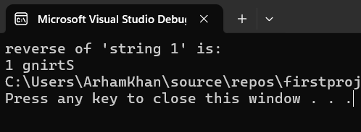
TASK 5:
INCLUDE Irvine32.inc

.data
even_table dword 10,14,18,22,26
rowSize = ($-even_table)
DWORD 30,34,38,42,46
DWORD 50,54,58,62,66
rind dword 0
cind dword 0
var dword 5
gap byte " ",0
prompt byte "2d array: ",0

.code
main PROC
mov edx, offset prompt
call writestring
call crlf

mov ecx,lengthof even_table*3
mov eax,ecx
mov ebx,offset even_table
l1:
mov eax,0
mov eax,rowSize
mul rind
add ebx,eax
mov esi,cind
mov ax,[ebx+esi*TYPE even_table]
movzx eax,ax
call writedec
mov edx,offset gap
call writestring
inc cind
mov eax,cind
cmp eax,var
je iaa
jmp j1
iaa:
cmp edx,15
je j2
call crlf
add var,5
mov eax,0
j1:
loop l1
j2:
exit
main ENDP
END main

